Google Maps and Places (April 2026 version)
In this workshop, you will learn to create an interactive map based on the Google Maps and Google Places APIs.

Part 1 – Enable APIs
First, you need to enable the Google Maps and Google Places APIs:
- Visit the API library: https://console.cloud.google.com/apis/library
- (You might have to select or create a project at the top.)
- Find and click on the Maps JavaScript API.
- Click on the “Enable” blue button and wait until it’s done.
- Go back to the API library: https://console.cloud.google.com/apis/library
- Find and click on the Places API. (the standard one, not the “new” one)
- Click on the “Enable” blue button and wait until it’s done.
If you have done the above correctly, both APIs should be listed in the “Enabled APIs”:
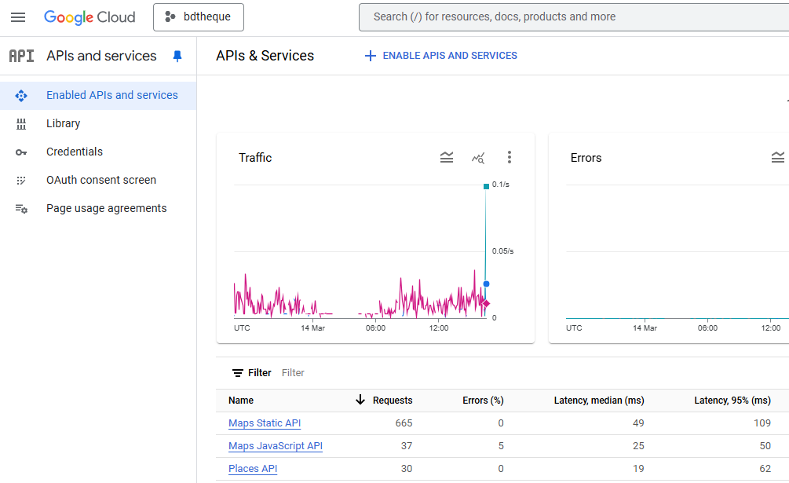

Part 2 – Credentials
Next, you need to create an API key, and restrict its access.
- Click on “Credentials” in the menu on the left.
- Press “Create credentials” at the top, then “API Key”:
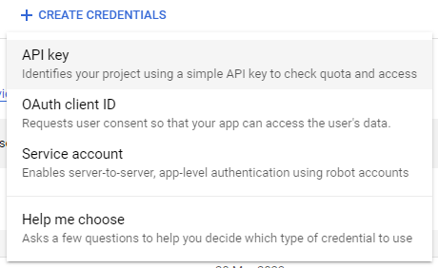
- A window pops up on the right:
  - Give your key a name of your choice
  - Under “APIs that can be accessed using this key”, search for a select the 2 APIs we enabled in Part 1
  - Under “Restrict your key to reduce security risks”, under the “Application restrictions” subheading, select “Websites”. Under “Website restrictions” below, press “Add” and enter “https://mi-linux.wlv.ac.uk/~0123456/*”, where 0123456 is your student number… and don’t forget the “*”.
  - Press “Create”, wait a few seconds, then copy and paste your API key, so that you can use it in Part 3.
  - Please note you can change the above at a later date, by selecting “Edit API key” in the list of keys.

Part 3 – Create your first Google Maps
You should now be able to create your own Google Maps… let’s give it a go!
Create a file called “map.html”, and copy and paste the following code inside the file:
<!doctype html>
<html lang="en">
<head>
<meta charset="utf-8">
<meta name="viewport" content="width=device-width, initial-scale=1">
<title>My photo map</title>
<link href="https://cdn.jsdelivr.net/npm/bootstrap@5.3.0-alpha3/dist/css/bootstrap.min.css" rel="stylesheet">
</head>
<body>
<div class="container-md mt-2">
<h1>My photo map</h1>
<div class="form-inline ml-auto">
<input id="search-places" class="form-control mb-2" type="text" placeholder="Search" />
</div>
<div id="map_canvas" style="width:100%;height:600px"></div>
</div>

<link href="https://cdn.jsdelivr.net/npm/bootstrap@5.3.3/dist/css/bootstrap.min.css" rel="stylesheet">
<script defer src="https://maps.googleapis.com/maps/api/js?key=your_api_key&callback=initMap&libraries=places"></script>

<script>

function initMap() {

// Set map options
var latlng = new google.maps.LatLng(46.92, 16.96);
var myOptions = {
zoom: 4,
center: latlng,
mapTypeId: google.maps.MapTypeId.TERRAIN,
scrollwheel: true,
streetViewControl: false,
mapTypeControl: true,
gestureHandling: "greedy"
};

// Create map
map = new google.maps.Map(document.getElementById("map_canvas"), myOptions);
}

</script>
</body>
</html>

Comments on the code (colour coded):
- We are using Bootstrap yet again, because it rocks
- This is where we include the Google Maps API.
  - Please make sure you specify your own API key, see part 2.
  - Note that we specify which “callback” function should be called when the API has finished loading. In our case, the function below is called “initMap()”.
  - Note that we also include the “Places” library, as we want to use the Google Places API later on.
- This object contains the options we want for our maps. Try to change them, add more etc. see documentation here.
You will need to upload your file onto mi-linux, using FileZilla. Hopefully you know how to do this by now, but here are some basic instructions.
Here is mine (remember you can look at the code in the developer tools!): https://mi-linux.wlv.ac.uk/~in9352/google-cloud/map-01.html
Remember to look out for errors in the console if your map is not displaying. A “RefererNotAllowedMapError” error means that you have not set your key properly, i.e. you are accessing a Google API from a URL not permitted by the key – see part 2, section 6 for more details.

Part 4 – Adding Google Places
The Google Places API allows you to find businesses, cities, places of interest etc. and obtain information and photos about them. Let’s use the API to search for places and display them on our map with a single photo.
Add the following code right after the “map = new google.maps.Map” line:
// Create the search box and link it to the UI element.
const input = document.getElementById("search-places");
const searchBox = new google.maps.places.SearchBox(input);
searchBox.addListener("places_changed", () => {

// Get places from response
const places = searchBox.getPlaces();
if (places.length == 0) {return;}

// Go to correct place on map
map.setZoom(13);
map.panTo(places[0].geometry.location);

// Remove existing marker
if (typeof marker !== 'undefined')
marker.setMap(null);

// Add new marker
marker = new google.maps.Marker({
position: places[0].geometry.location,
title:places[0].name
});
marker.setMap(map);
});

Comments on the code:
- These lines bind a Google Places search box to our HTML “search-places” text box.
- These lines add a marker on our map, using the coordinates from the Google Places response.
- Don’t forget the last line with the 2 closing brackets!
All being well, you should now be able to search for a place, using the search box at the top. When selecting a result, the map should take you there, and place a marker on it. Here is my working version: https://mi-linux.wlv.ac.uk/~in9352/google-cloud/map-02.html

Part 5 - Displaying a single photo when clicking the marker.
Finally, let’s display a single photo of the place we have searched for and selected.
Add the following code immediately after the “marker.setMap(map);” line:
// Create info window for marker
const infowindow = new google.maps.InfoWindow({
content: '<img class="w-100" src="' + places[0].photos[0].getUrl() + '">'
});
marker.addListener("click", () => {
infowindow.open(map, marker)
});
Comments on the code:
- First, we create an “Info Window”, and set its content to the 1st photo in the response.
- Then, we specify that the Info Window should open when we click on our marker.
All done! Now when clicking on the marker, a nice photo of the place should be displayed. Here is my working version: https://mi-linux.wlv.ac.uk/~in9352/google-cloud/map-03.html

Part 6 – Going further.
Further ideas to explore:
- Display the first 3 photos of each location, using a Bootstrap Carousel.
- Handle special cases, such as places with no photos.
- Display the place’s name and website above the photo.
- Advanced: allow users to save pins to a Firestore, then load them again next time they visit!

